Test_1bin_ocnice toy model

1. To compile the OASIS3-MCT coupler:
- Go into directory oasis3-mct/util/make_dir
- In each new terminal you open, do :
module purge
module load intel intelmpi
alias ferret="xterm -e ferret &"
- Adapt the value of $COUPLE and $ARCHDIR in your platform header (see example therein)
- Adapt the "make.inc" file to include your platform header in the TopMakefileOasis3.
- Type "make realclean –f TopMakefileOasis3" and then "make –f TopMakefileOasis3"
- The libraries "libmct.a", "libmpeu.a", "libpsmile.MPI1.a" and "libscrip.a" that need to be linked to the models are available in the directory $ARCHDIR/lib
- To compile the test_1bin_ocnice model:
- Go into directory oasis3-mct/examples/test_1bin_ocnice
- Type "make clean; make" (note that the Makefile in this directory automatically includes your OASIS3-MCT header makefile – see the first line in the Makefile)
- The executable ocnice is available in the current directory.
- To run the ocnice component models:
Edit the script run_1bin_ocnice to adapt it to your platform and execute it.
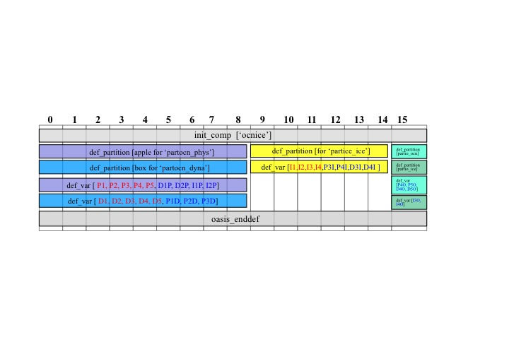
The results are now in subdirectory $rundir defined in the script. This toy model reproduces the coupling between 5 sub-components of component “ocnice” in the “ocnice” executable. Two sub-components, defining grids with respectively a “partocn_phys” partition and a “partocn_dyna” partition, run sequentially on tasks 0-8 and exchange coupling fields. These two sequential sub-components run concurrently with and exchange coupling fields with a third sub-component defining a grid with partition “partice_ice” on tasks 9-14. Two additional sub-components, running sequentially and defining grids with partitions “partio_ocn” and “partio_ice” on task 15, run concurrently and exchange coupling fields with the first 3 sub-components. The sequence of calls to oasis_init_comp, oasis_def_partition and oasis_def_var reproduced by ocnice on the different tasks is illustrated on Figure 1, while the coupling exchanges of the different fields between the different tasks is detailed on Figure 2.

Figure 1: The sequence of calls to oasis_init_comp, oasis_def_partition and oasis_def_var reproduced by the different tasks of ocnice.

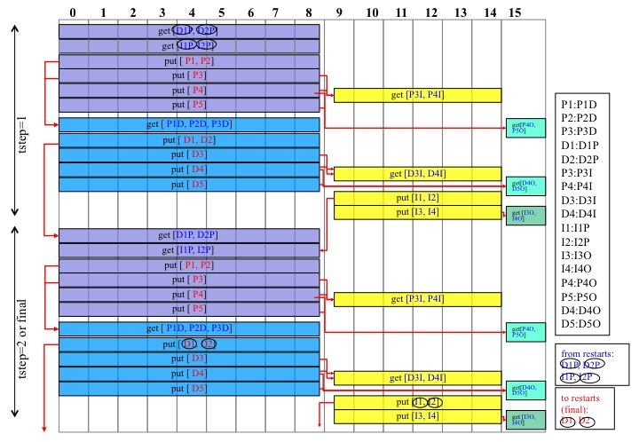

Figure 2: Coupling exchanges of the different fields between the different tasks of ocnice.

